Midland Employment Support Agency Ltd.
Trading as

EmployAbility Midlands

ANNUAL REPORT 2017

EmployAbility– “Building Futures Together”
www.employabilitymidlands.com

Chairperson’s Foreword 2017
Once again on behalf of the Board of Directors of EmployAbility Midlands it is my pleasure to present our Annual Report for 2017. Yet another busy year for the company with some key changes taking affect and requiring significant preparation during 2017. As part of preparation for the General Data Protection Regulation, Initial guidance was sought on behalf of 23 EmployAbility CLG’s which was used in conjunction with A 12 step guide issued by the Data protection Commissioner to commence preparations for the changes scheduled for May 25th2018.
EmployAbility Midlands along with all others is committed to implementation of a standardised governance code to enhance and improve the effectiveness of the current governance structures. Other actions agreed include a structured relationship with DEASP, the adequate resourcing of the national Director’s forum the implementation of a fit for purpose Management Information system. We are committed to playing our part, through agreed sub-group structure, in agreeing and developing the most suitable strategy for implementing each recommendation.
On foot of recommendations from Indecon report, Directors submitted proposal to DEASP regarding the establishment of a national EmployAbility Secretariat which was accepted by the Department who gave a commitment to fund same from 2018.
Other highlights of 2017 include the approval by DEASP to our proposal to fund an extra part time Employment Officer to respond effectively to the increased demand we have experienced in recent years.
EmployAbility Service made a national submission to Comprehensive Employment Strategy – Action 5.1 (Provide coordinated and seamless support). A cross-departmental working group, facilitated by the NDA, came together to develop a new policy approach to supporting people with disabilities, including those with high support needs, to find and retain employment. The working group undertook to consult with a wider group including EmployAbility on this model to ensure all issues are considered when shaping the final version of the policy and plan accordingly.
The Board would like to acknowledge the support of the Department of Employment Affairs & Social Protection in providing the core funding to deliver the service. Our Employment Officers continue to enjoy good working relationships with local Intreo personnel throughout the Midlands, enabling us to provide the best possible service to our job seekers
Finally, I would like to acknowledge the time, support and expertise given freely by my fellow voluntary Directors, in guiding the company toward achieving its, mission and objectives and the staff for implementing the company’s vision. I would like to make particular mention here of our Coordinator, Mr. Tony Reilly, for his commitment and dedication in his management of the service.

Susan Ryan
Chairperson

COMPANY MISSION
“Supporting people with disabilities into paid employment while providing effective solutions to employers’ staffing needs”

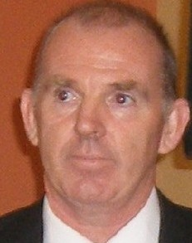
Introduction

Yet again in 2017, our entire team worked hard to match our job seekers with suitable opportunities by striving to establish new links and develop existing relationships with many willing employers throughout the Midlands. Our outcomes consistently reflect an effective process and approach so, well done to our entire team. Demand for the service has grown steadily over the past year however I would like to acknowledge the funding and support provided by DEASP in 2017 in response to our proposal to employ an extra part time Employment Officer.
The EmployAbility service, which is available throughout Ireland, is funded by the Department of Employment Affairs & Social Protection and is designed to provide the critical supports required by Jobseekers with a disability or support need wishing to join the open labour market. The EmployAbility service also provides the supports Employers require to employ a person with a disability and to assist with employee integration into the workforce.
One of the highlights for the EmployAbility service nationally was confirmation from DEASP to resource the establishment of a dedicated secretariat/development worker for the service. The proposed role of the secretariat would be to facilitate:
- Communications – act as a liaison person between 23 Boards of Directors and DSP.
- Develop an implementation strategy and plan for Indecon Report recommendations
- Develop and agree KPIs
- Statistics and reporting
- International best practice
- Enhance Programme Governance.
Preparation for the General Data Protection Regulation required initial guidance for the 23 EmployAbility CLGs which was used in conjunction with A 12 step guide issued by the Data Protection Commissioner to commence preparations for the changes scheduled for May 25th, 2018. EmployAbility Midlands coordinated a specific training event which saw the formation of 4 working groups who undertook specific pieces of work including drafting of relevant policies and drafting of appropriate document retention periods.
Due to continued demand for service the Board decided that a formal application for an extra full time Employment Officer was necessary and so a proposal to this effect was made to DEASP in our annual 2018 budget submission at year end.
Finally, a special word of thanks to our voluntary Board of Directors who continue to freely give their time, knowledge and expertise in governing the company and guiding the future development of the service.
Tony Reilly
Co-ordinator.

Administrator’s Update – Head Office

2017 has been a particularly busy year in my role as Administrator due to the introduction of new staff members and increased enquiries for our service. As the Administrator, I provide administrative support to our Co-ordinator and Employment Officers. I instigate the implementation of statutory office policies and procedures and ensure compliance by conducting regular audits.

I am responsible for the completion of our Computerised Wages, Management Accounts and Annual Budgets. I keep a record of all meetings and take minutes at our regular team meetings. I manage the internal and external communications necessary for the efficient running of our head office here in Tullamore.

EmployAbility Service

“Supporting people with disabilities to secure and maintain employment.”
While initially based on the Supported Employment model which was developed for people with learning difficulties, the National EmployAbility Service demonstrates that the service can successfully be applied to all disability groups.
As a strategy for enabling people with disabilities to access open employment, EmployAbility Service is based on the following key principles:

- Placements in the open labour market
- Support throughout the entire process
- Paid employment
- Integration

EmployAbility supports Job Seekers:
- To identify skills and abilities
- By facilitating work experience placements
- To find a suitable job
- With ongoing support during and after work
EmployAbility supports Employers by:
- Providing advice and assistance on grants and financial supports
- Helping to recruit the right person
- Providing jobseekers on a short trial basis, free of charge
- Providing on-site support with induction and training
- Providing jobseekers to fill positions with short or irregular hours

National EmployAbility Targets
Current targets require that each Employment Officer endeavours to:
- Work with 25 job seekers at any time
- Maintain 50 % of that number in employment
- Ensure that 50% of job seekers who exit the service do so while in employment.

Regional Update - Longford
There is a high demand for the EmployAbility service here in Longford as our waiting list shows. Our referrals come from a variety of sources including DSP, National Learning Network, Mental Health Service and many self-referrals also.
Without the generosity and a willingness to ‘give it a go’ of the employers throughout the county our jobs would be next to impossible. They never fail to help us with work experience opportunities and job offers too, for our job-seekers. We appreciate their show of faith in us and our service.
We enjoy a great working relationship with our Intreo service here in the DSP. The staff are extremely accommodating with appointments for clients, following up on queries and so on, and are very professional in all our dealings with them.
We continue to be represented on the committee of the Services to the Unemployed in Co Longford and meet regularly throughout the year to work together on finding solutions to the unemployment situation in the county, with EmployAbility’s focus being that of unemployed people with disabilities.
Thanks to the committee and staff of Granard Area Action Group for the use of their offices where we provide an Outreach service once a month.

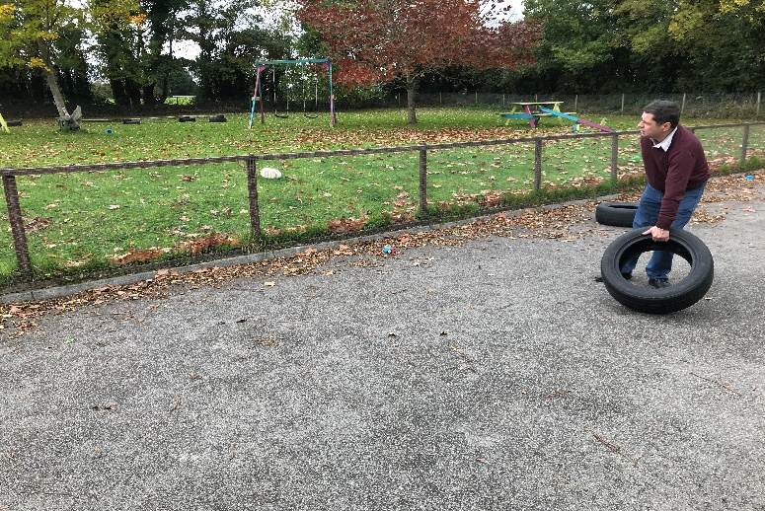
Groundskeeper in local creche.

Regional Update - Laois
Referrals for 2017 were very steady and came through the Department of Social Protection’s Intreo Office, Portlaoise. The clients were referred to there from various organisations such as National Learning Network (NLN), HSE Occupational Therapists, Irish Wheelchair Association (IWA), Acquired Brain Injury (ABI) and Self-Referrals etc. Attending the Jobs club once a month to inform the participants of our service also helped gain awareness of our service within the community.
Our service here in Laois has a very good relationship with the staff in the Intreo Office in Portlaoise and Tullamore. They are very good at dealing with queries that we or any of our clients would have. We are indebted to the CE Scheme Supervisors and HSE offices who accommodate us very well by allowing us the use of office space in which to meet our clients, on an outreach basis, around the different towns and villages of Co Laois and Offaly. Also, the libraries in both Edenderry and Portarlington proved to be invaluable in providing meeting spaces for us to meet clients.
We would like to take this opportunity to thank the employers of Co Laois and Offaly for their time and their continued support they show to our service. Most employers were very accommodating in 2017 and gave work experience where they could and at times this work experience turned into paid employment.
During the year we attended a training course delivered by Orlaith McManus around Boundary Management and Motivational Interviewing which was very interesting. Our trip to Edinburgh as a team was a great success. Along with our team meetings these trips are invaluable as we are situated in different counties in the Midlands and don’t get to see each other daily, so this is a great way to catch up. Overall 2017 was a productive year for Co Laois and Offaly.

Achievements
Delivered service to 264 Participants
Sourced 109 new referrals in 2017
A total of 110 job seekers exited our service in 2017
A total of 158 individuals achieved a positive outcome as follows

- New jobs secured in the open labour market 67
- Formal work experience 75
- Community Employment 02
- Referred for further vocational skills training 14

Employment Disability Categories 2016

Employment Categories 2017
Other Category includes – Butcher, Horticultural, Porter, Agri consultant, Mechanics.

Regional Update – Westmeath

Mullingar
Mullingar progressed well in 2017. Referrals were very strong and we had a high number of people exiting the service in employment. We worked with a broad range of people with a variety of disability types. We continue to work with a variety of agencies in the North Westmeath area including The Mental Health Team, HSE, DSP, NLN, CE Schemes, Jobs Club, etc.
2017 saw us continue to work well with Intreo to develop the service and make it easier for potential clients to access the service. We increased the number of jobs that we obtained and 90% of our jobs were secured using the Wage Subsidy Scheme. Most placements began by first securing a work experience or job trial so that the client could demonstrate their ability to the employer.
We did a lot of work to promote the service in the Mullingar area in 2017. Presentations were given at every Jobs Club. We attended the Information Day for People with Disabilities which was organised by The Westmeath Disabilities Forum.
We strived to raise the awareness of our service among employers in the area. We attended the Westmeath Enterprise Information Day, met with and gave information about our service to a lot of employers. In 2017, some of the employers with whom we secured paid employment included Shanette, Slanemore Farms, Lynn Antiques and Woodlawn Montessori. These placements were obtained through initial work experience and job trials.
We continue to promote the service through Media. We have a large number of Facebook followers who track the vacancies that are linked on our page daily. We promote our website to employers on a regular basis.
Overall, we witnessed a strong year for Mullingar in 2017 and it is our intention to keep the momentum going.
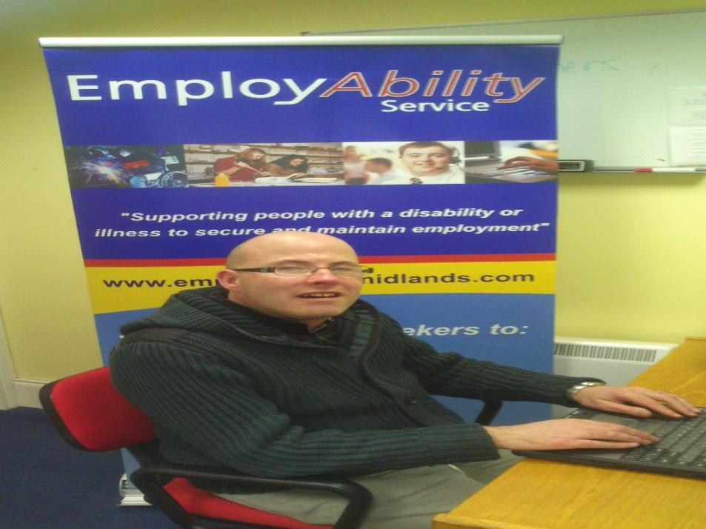
Karl at work in HSE

Excellence Through People
As people are one of EmployAbility’s core assets, the twenty-three centers had a desire to maintain an industry recognised Human Resource Standard to effectively benchmark themselves against best in class and this was their rationale for their application to NSAI for Re-Assessment to Excellence Through People Certification.
The National EmployAbility service is very employee focused and staff members interviewed felt valued, well trained, empowered and respected at work. They also felt that the organisation has a good working culture with open and transparent communication in place. Placement and progression targets for each job coach are prioritised in each individual network and results are benchmarked nationally with best practice shared among different networks.
Excellence through People is Ireland’s national standard for Human Resource Development which EmployAbility secured through aligning best practice Human Resource Management systems with Business Development. EmployAbility Midlands continues to hold the ETP Award.
The Business Management and Human Resources policies, procedures and practices witnessed during the five-day ETP assessment reflect good practice as there is a culture of high-quality service provision and equally high people engagement that creates a vertically integrated organisation with a strong focus on achieving the organisation’s stated objectives.
The six EmployAbility Centres that were audited for the Re-Assessment were, in general, compliant across the six sections of the ETP Scheme with strengths in Effective Communications, Business Planning, Learning & Development, Leadership and Employee Wellbeing.

The levels of employee engagement across all departments towards achieving EmployAbility’s business objectives is a major contributor to the organisation’s success in meeting its Key Performance Indicators in each of its twenty-three centres. Having held discussions with the National Co-Ordinator, 5 Centre Co-Ordinators, 16 Job Coaches, Employment Facilitators and Administration staff, the assessor was impressed with the positive feedback with the levels of support in relation to people development and job enrichment and how this contributed to organisational success.
The areas for improvement identified in this report are intended to add value to the National EmployAbility Service as part of its continuous improvement process.
In conclusion, it is recommended that the National EmployAbility Service continue to be certified to Excellence Through People Scheme 1000:2012.

Referrals
The working relationship that exists between our Employment Officers, DSP Employment Service’s staff and disability service providers is crucial to the success of the service. Sharing of information, expertise and consultation between the organisations has ensured that the end user receives a professional service in an effective and efficient manner. This approach had a significant impact on the numbers of people presenting to EmployAbility Midlands service in 2017, as the statistics below verify, and as a result, we have had to introduce waiting lists in some counties. We received 109 new referrals in 2017 and the chart below gives a breakdown of that number.

Referral Source 2017

Referrals by Disability Category 2017

Workplace & Wage Subsidy Scheme
Traditionally, we have found that some of our service users don’t always demonstrate their abilities at interviews. The Workplace Scheme allows for job seekers to avail of a work experience placement with employers for a 5-7-week period at no cost to the employer and receive €20 per week subsistence from the EmployAbility organisation. Results are indicating that this scheme has the potential to secure more employment opportunities for our job seekers.
The Wage Subsidy Scheme is a DSP/Intreo workplace support which provides financial support to employers to encourage them to employ people with disabilities where a shortfall in productivity exists. Where appropriate, we have supported employers in applying for this scheme & we firmly believe that the combination of support from WSS & EmployAbility were crucial to securing an increased number of employment placements. The Wage Subsidy Scheme is currently under review.

Marketing and Promotion

Our website is proving to be a very useful source of guidance and information for job seekers and employers. The total website hits for the year were 5714, on a par with last year’s figures. We are constantly working to improve our website with up to date information and we post articles of interest/job vacancies etc regularly on our Facebook page.

Providing a comprehensive service to all our stakeholders is of paramount importance to us and we continue to invest time and effort into developing effective networks. In 2017 we continued to promote the service by regularly delivering presentations to employers and organisations; we were invited to attend and provide stands at various Information/Employer Awareness Days throughout the Midlands.

As part of our marketing strategy, EmployAbility Midlands has put significant effort and time into developing effective networks to promote a quality service.
We are represented on:
- The National Co-ordinators’ Forum
- Westmeath Disability Working Group
- Longford Services to the Unemployed
- Athlone Mental Health Association
- Midland Business Network

Participation in the above has enabled EmployAbility Midlands to contribute to the development of best practice in the service and to address issues to remove the barriers to employment for people with disabilities. Establishing and developing effective networks encourages, promotes and supports EmployAbility Midlands in delivering a quality service to our customers. A good inter-agency working relationship has assisted us in:
- Identifying potential referrals
- Identifying employment opportunities
- Sharing of information
- Identifying areas of best practice (nationally and internationally)
- Providing the best possible service for the end user.

Board of Directors

Ms Susan Ryan - Chairperson
Manager
(Citizens Information Centre)

Mr Tony Corry – Secretary Mr Adrian Stewart
Sector Manager Regional Manager
(HSE) (NLN)

Tony McCormack Mr Hugh Farrell
President Regional Manager
(Midlands Gateway Chamber) (I.W.A)

Mr Sean Ryan
Training & Business Consultant
(Self Employed)

There were 5 Board meetings held in 2017 along with company AGM. Details as follows:
21st^{th} Feb – Susan Ryan, Sean Ryan & Tony Corry
25th Apr – Susan Ryan, Tony Corry & Sean Ryan
14th Jul – Susan Ryan, Tony McCormack & Tony Corry
11th Sept AGM – Tony McCormack, Hugh Farrell & Tony Corry
11th Sept BOD meeting– Tony McCormack, Hugh Farrell & Tony Corry
5th Dec – Susan Ryan, Adrian Stewart & Hugh Farrell

Governance Code Sub Group – Tony Reilly, Susan Ryan & Adrian Stewart.
HR Sub Group – Hugh Farrell & Sean Ryan
Finance Sub Group – Susan Ryan, Tony Corry, Sean Ryan, Hugh Farrell, Adrian Stewart & Tony McCormack.

EmployAbility Midlands - Locations
In 2017, EmployAbility Midlands provided a service in the counties of Laois, Offaly, Longford and Westmeath. Details of office locations are as follows:
TOWN | LOCATION
TULLAMORE  (Central Office) | Unit 53, 1st Floor, Bridge Centre, Tullamore,  Co. Offaly Tel: 057 93 23901 / 086 3873 047 (Martina)
MULLINGAR | C/o Friary House, Friars Mill Road, Mullingar,  Co. Westmeath Tel: 086 8338 027 (Daniel)
MOUNTMELLICK | C/o Mountmellick Development Association, Irishtown,Mountmellick, Co. Laois Tel: 086 3873 056 (Sandra) 086 1451074 (Patricia)
LONGFORD | C/o Dawn learning Centre, Grafton Court, Longford,  Co. Longford Tel: 086 3872 855 (Brenda)
ATHLONE | C/o Parish Centre, Chapel Street, Athlone,  Co. Westmeath Tel: 086 3872 496(Joan) 086 8337 946 (Rosemarie)

