Midland Employment Support Agency Ltd.
Trading as

EmployAbility Midlands

ANNUAL REPORT 2016

EmployAbility– “Matching Abilities with Opportunities”
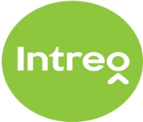

Chairperson’s Foreword 2016
On behalf of the Board of Directors of EmployAbility Midlands it is my pleasure to present our Annual Report for 2016. Our service aims to match job seekers’ abilities with employment opportunities and provides the critical supports for job seekers with disabilities and employers, that enable successful and sustainable placements to be sourced, maintained and developed. Success is only possible when employers are open and willing to give people with disabilities the opportunity to participate in a working environment and in this regard, I can confirm that employers in the midlands have not being found wanting.
One of the main highlights of 2016 was the publishing of an independent evaluation of the EmployAbility Service by Indecon Economic Consultants, which will guide the future development of the service. The overall conclusion of the report indicates that the EmployAbility service has achieved a high level of support and has been well received by both clients and employer organisations, suggesting that the supported employment service model remains valid as a framework to deliver improved employment outcomes for jobseekers with a disability. Challenges identified include; responding effectively to increased demand for the service which in turn will require a more streamlined service nationally, functioning under an enhanced governance and oversight framework with more effective targeting of prospective clients. We are committed to play our part, through agreed sub-group structure, in agreeing and developing the most suitable strategy for implementing each recommendation.
At EmployAbility Midlands, we have already begun work on one of the recommendations by signing up to adopt the new Governance Code for community, voluntary and charitable organisations and are now registered with the Corporate Governance Code of Ireland registered as being “on the Journey”.
In line with the Government’s Comprehensive Strategy for people with Disabilities, we believe that our service continues to play a vital role in both maintaining and increasing the number of people with disabilities in gainful and meaningful mainstream employment. EmployAbility Midlands will continue to work toward delivering a number of the key strategic actions in this document, including; Providing Bridges and Supports for Work, Making Work Pay and Engaging Employers.
The Board would like to acknowledge the support of the Department of Social Protection in providing the core funding to deliver service. Our Employment Officers continue to enjoy good working relationships with local Intreo personnel throughout the Midlands enabling us to provide the best possible service to our job seekers
Finally, I would like to acknowledge the time, support and expertise given freely by my fellow voluntary Directors, in guiding the company toward achieving its vision, mission and objectives, the Coordinator, Mr Tony Reilly who supports the Board in its function and the staff for implementing the company’s vision.

Susan Ryan
Chairperson

COMPANY MISSION
“Supporting people with disabilities into paid employment while providing effective solutions to employers’ staffing needs”

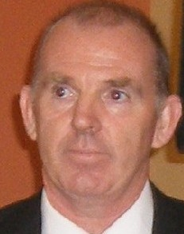
Introduction
Over the past 12 months, demand for the service has grown to its highest level since EmployAbility Midlands service was established in 2004. The service, which is available throughout Ireland, is funded by the Department of Social Protection and is designed to provide the critical supports required by Jobseekers with a disability or support need wishing to join the open labour market. The EmployAbility service also provides the supports Employers require to employ a person with a disability and to assist with employee integration into the workforce.
Having exhausted all available approaches to manage our waiting list, the Board decided that a formal application for an extra Job Coach was the only realistic option and so a proposal to this effect was made to DSP in our annual budget submission at year end.
In August of 2016, the eagerly awaited evaluation of the national EmployAbility service was launched at an event in Dublin Castle. The report, produced by Indecon International Economic Consultants examined; the effectiveness and the efficiency of the service; the appropriateness of the governance structures; and the scale and scope of the service provision. It also presented proposals for the future delivery of the service and feedback in the report clearly showed that 98% of (1200) employers surveyed and 92% of (1200) job seekers surveyed had a very positive experience of the service. The national EmployAbility Service now looks forward to working closely with the Department to implement the recommendations of the report.
In 2016 we signed up, at DSP’s request, to confirm our interest in an exciting HSE proposal in developing a dedicated employment and education service for young individuals who experience first episode psychosis. The proposal is called “Early Intervention in Psychosis: Supported Employment/Education using Individual Support Model for First Episode Psychosis” We eagerly await further developments with this proposal.
This year saw the Company change its name form (Ltd to CLG) in order to comply with new Company Law regarding companies with charitable status.
Yet again in 2016, our entire team worked hard to match our job seekers with suitable opportunities by striving to establish new links and develop existing relationships with many willing employers throughout the midlands. Our outcomes consistently reflect an effective process and approach so, well done to our entire team.
Finally, a special word of thanks to our voluntary Board of Directors who continue to freely give their time knowledge and expertise in governing the company and guiding the future development of the service.
Tony Reilly
Co-ordinator.

Administrator’s Update – Head Office

2016 has been a particularly busy year in my role as Administrator due to the introduction of new staff members and increased enquiries for our service. As the Administrator, I provide administrative support to our Co-ordinator and Employment Officers. I instigate the implementation of statutory office policies and procedures and ensure compliance by conducting regular audits.

I am responsible for the completion of our Computerised Wages, Management Accounts and Annual Budgets. I keep a record of all meetings and take minutes at our regular team meetings. I manage the internal and external communications necessary for the efficient running of our head office here in Tullamore.

Regional Update - Offaly
In June 2016 I joined the team and have had an incredibly supported integration into my new role as Employment Officer and member of the EmployAbility Midlands Team. This role required many introductions, chartering a strong working relationship with the Case Officers in Tullamore and Edenderry, acquainting businesses throughout the County with our service. It involved delivering presentations, circulating promotional brochures and information leaflets be to Business Network meetings, Offaly Local Enterprise office while also engaging with Laois/ Offaly Education and Training Board.
Client referrals have increased facilitated by ongoing contact with the Bannon Centre, Acquired Brain Injury Ireland, HEAR, NCBI, NLN, Rehabcare and DSP. Placements with employers have increased, with many new employers availing of the Wage Subsidy Scheme along with the support of the EmployAbility Employment Officer successfully. A variety of new employers (large and small) have engaged with us, while existing employers continue to support and engage with our service.
Work experience placements provide the opportunity for our jobseekers to demonstrate their abilities and to experience different job types while allowing the employer to see first-hand what each individual has to offer.
We gratefully acknowledge the continued support of all the employers across the county without whom the service wouldn’t be the success it is.
Finally, I would like to acknowledge the opportunity to attend a training course on Mental Health Awareness, which I feel will assist greatly in supporting our job-seekers into sustainable, mainstream employment.

EmployAbility Service

“Supporting people with disabilities to secure and maintain employment.”
While initially based on the Supported Employment model which was developed for people with learning difficulties, the National EmployAbility Service demonstrates that the service can successfully be applied to all disability groups.
As a strategy for enabling people with disabilities to access open employment, EmployAbility Service is based on the following key principles:

- Placements in the open labour market
- Support throughout the entire process
- Paid employment
- Integration

EmployAbility supports Job Seekers:
- To identify skills and abilities
- By facilitating work experience placements
- To find a suitable job
- With ongoing support during and after work
EmployAbility supports Employers by:
- Providing advice and assistance on grants and financial supports
- Helping to recruit the right person
- Providing jobseekers on a short trial basis, free of charge
- Providing on-site support with induction and training
- Providing jobseekers to fill positions with short or irregular hours
National EmployAbility Targets
Current targets require that each Employment Officer endeavours to:
- Work with 25 job seekers at any time
- Maintain 50 % of that number in employment
- Ensure that 50% of job seekers who exit the service do so while in employment.

Regional Update - Longford
The demand for the EmployAbility service here in Longford is steadily increasing year on year. Our referrals come from a variety of sources including DSP, National Learning Network, Mental Health Service and many self-referrals also.
We continue to be represented on the committee of the Services to the Unemployed in Co Longford and meet regularly throughout the year to work together on finding solutions to the unemployment situation in the county, with EmployAbility’s focus being that of unemployed people with disabilities.
Employers throughout the county always step up to the mark with work experience opportunities and job offers for our job-seekers, they are instrumental in helping to dispel the negativity around employment and disability, as our statistics will show. We appreciate their show of faith in us and our service.
Thanks to the committee and staff of Granard Area Action Group for the use of their offices where we provide an Outreach service once a month.

Indecon Report
In 2016, Indecon International Economic Consultants completed an independent evaluation of the EmployAbility service and submitted the report to the Department of Social Protection (DSP).
The EmployAbility service is a national employment service dedicated to improving employment outcomes for jobseekers with a disability. In line with the United Nations Convention on the Rights of Persons with Disabilities, the service’s overall vision is to support people with a disability to secure and maintain employment while aiming to stem the flow of people with disabilities and extra support
needs into long term unemployment by facilitating integration into suitable and fulfilling mainstream employment.
In particular, the evaluation has examined; the effectiveness and the efficiency of the service; the appropriateness of the governance structures; and the scale and scope of the service provision. It also presented proposals for the future delivery of the service.
The overall conclusion of the report indicates that the EmployAbility service has achieved a high level of support and has been well received by both clients and employer organisations, suggesting that the supported employment service model remains valid as a framework to deliver improved employment outcomes for jobseekers with a disability. Challenges identified include; responding effectively to increased demand for the service which in turn will require a more streamlined service nationally, functioning under an enhanced governance and oversight framework with more effective targeting of prospective clients.
Recommendations emanating from this report fall into two categories; Strategic and Operational. Strategic Recommendations include; more rigorous linking of future funding with the achievement of defined labour market activation outcomes; streamlining of EmployAbility structures; ongoing assessment of the geographic pattern of demand for service and a review of the eligibility criteria for the service.
Operational Recommendations include; Intreo case management to ensure that individuals are directed to the most appropriate service; a review of programme monitoring indicators; updating of the EmployAbility Operating Standards; EmployAbility companies to sign up to and implement a consistent Corporate Governance Code and finally to develop formalised communication and engagement mechanisms between DSP and the EmployAbility service.
It was agreed that the Coordinators of the 23 EmployAbility companies would form sub -groups to look at each of these recommendations and in turn to meet with DSP and agree/develop the most suitable strategy for implementing each.
Further details can be found in the full Indecon report which is available on the DSP website www.welfare.ie.

Regional Update - Laois
Referrals for 2016 were very steady and came through the Department of Social Protection’s Intreo Office, Portlaoise. The clients were referred to there from various organisations such as National Learning Network (NLN), HSE Occupational Therapists, Irish Wheelchair Association (IWA), Acquired

Brain Injury (ABI) and Self-Referrals etc. Attending the Jobs club once a month to inform the participants of our service also helped gain awareness of our service within the community.
Our service here in Laois has a very good relationship with the staff in the Intreo Office Portlaoise. They are very good at dealing with queries that we or any of our clients would have. We are indebted
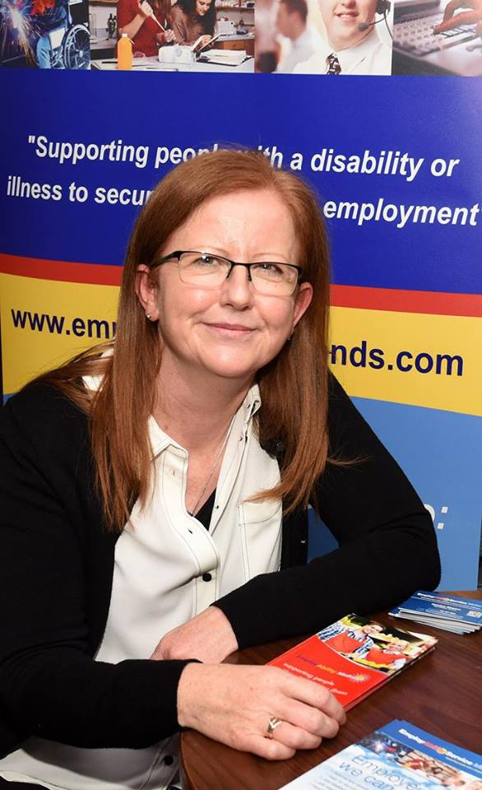
to the CE Scheme Supervisors and HSE offices who accommodate us very well by allowing us use of an office space in which to meet our clients, on an outreach basis, around the different towns and villages of Co Laois.
I would like to take this opportunity to thank the employers of Co Laois for their time and the continued support they show to our service. The majority of employers in Co Laois were very accommodating in 2016 and gave work experience where they could and at times this work experience turned into paid employment. At the beginning of the year we attended a motivational talk from Shane Martin which was a great way to start the year off. Along with my colleagues a useful team building/problem solving workshop was had at Petersburg Education Centre. Along with our team meetings these days are invaluable as we are situated in different counties in the Midlands and don’t get to see each other daily, so this is a great way to catch up. Overall 2016 was a productive year for Co Laois.

Achievements
Delivered service to 266 Participants
Sourced 116 new referrals in 2016
A total of 116 job seekers exited our service in 2016
A total of 137 individuals achieved a positive outcome as follows

- New jobs secured in the open labour market 65
- Internships secured 01
- Formal work experience 67
- Community Employment 01
- Referred for further vocational skills training 10

Regional Update – Westmeath

Mullingar
2016 was another strong year for referrals in Mullingar. We took a broad range of people with a variety of disabilities. We continue to receive referrals from various agencies in Mullingar including The Mental Health Team, HSE, DSP, NLN, etc. 2016 saw us further strengthen links with the now well established Intreo Service and we continue to work with them to develop the service and make it easier for clients to access our service and the supports that are available to them.
2016 saw an increase in the number of jobs obtained; 90% of our jobs were secured using the Wage Subsidy scheme and job placements began with us securing a work experience/job trial first so that the client could demonstrate their ability to the employer.
We continue to promote our service in North Westmeath. We gave presentations monthly at the Jobs Club. We attended several local information days including an information day for potential service users organised by The Westmeath Disabilities Forum.
We have also increased our efforts to promote the service among employers. In 2016, some of the Employers with whom we secured paid employment included Bridge Agri, Wild, Europasat, Mullingar Montessori, and Scantec. These placements were obtained through initial work experiences and job trials. We continue to operate an outreach service on demand in Castlepollard and Ballinacargy and this has led to increased service users from these areas.
We have also promoted the service through media. We successfully had an article published in the Westmeath Examiner about Employability Midland’s service to the people of North Westmeath and we continue to promote our service through Facebook and our website.
Overall, Mullingar is progressing very well. Referrals are constant and we have a high proportion of people exiting the service in employment and able to maintain this employment with little intervention from us.

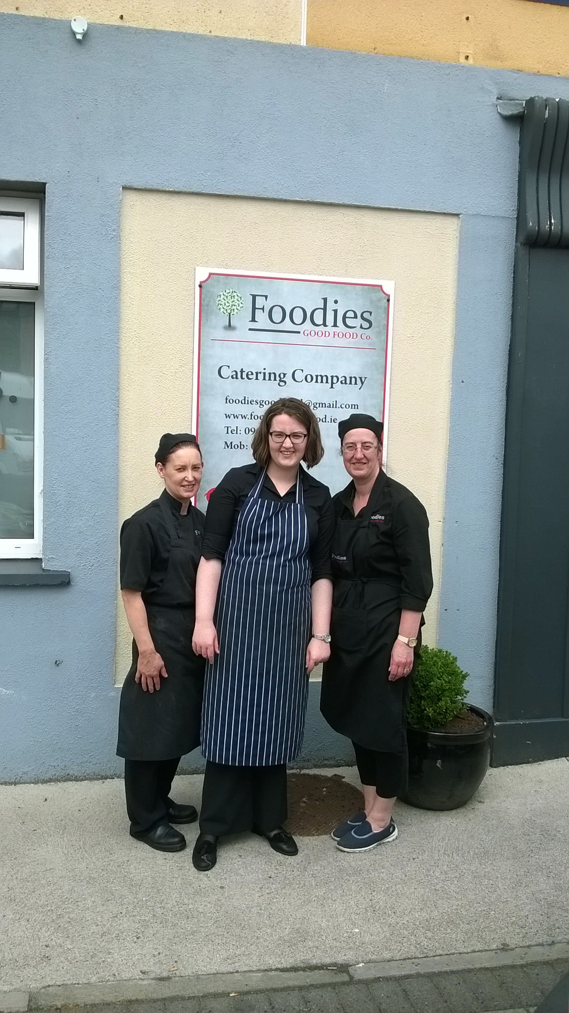
Athlone
The Athlone office of EmployAbility Midlands reported another successful year for 2016. The number of referrals were up on last year with most of their origins coming from the “Self-Referral” category followed closely by the local Jobs Club. Self-referrals are testimony to the successful marketing of our service coupled with satisfaction among current service users who promote the service through word of mouth.
Once again the employers of Athlone and surrounds have risen to the challenge and accommodated our clients with work experiences and, in most cases resulting in contracts of employment. Effective networking continues to be the key factor in securing employment and special thanks must go to the members of the Midland Business Network who continue to support the employment needs of our clients. Thanks must also be attributed to the local community groups and organisations who often offer work experience which is sometimes the client’s first ever experience in the world of work. Placements in Athlone Community Radio, St. Vincent de Paul, Simon and Parish organisations are invaluable for us as Employment Officers to correctly assess the client’s work ethic, ability and interests for other placements going forward to achieve their employment goal. Again in 2016, the new referrals came from various backgrounds with diverse skills and abilities. Successful employment opportunities were found for low skilled employees as well as those with higher level educational accomplishments.

Excellence Through People
In line with Excellence Through People’s (ETP) national standard for Human Resource Development, EmployAbility Midlands staff took part in BPS Ability Testing and BPS Personality Testing (Psychometric Testing) training which was facilitated by ETC Consult. We also attended a one day workshop facilitated by Psychologist Shane Martin.
Excellence through People is Ireland’s national standard for Human Resource Development which EmployAbility secured through aligning best practice Human Resource Management systems with Business Development. EmployAbility Midlands continues to hold the ETP Award.

Referrals
The working relationship that exists between our Employment Officers, DSP Employment Service’s staff and disability service providers is crucial to the success of the service. Sharing of information, expertise and consultation between the organisations has ensured that the end user receives a professional service in an effective and efficient manner. This approach had a significant impact on the numbers of people presenting to EmployAbility Midlands service in 2016, as the statistics below verify, and as a result, we have had to introduce waiting lists in some counties. We received 116 new referrals in 2016 and the chart below gives a breakdown of that number.

Workplace & Wage Subsidy Scheme
Traditionally, we have found that some of our service users don’t always demonstrate their abilities at interviews. The Workplace Scheme allows for job seekers to avail of a work experience placement with employers for a 5-7-week period at no cost to the employer and receive €20 per week subsistence from the EmployAbility organisation. Results are indicating that this scheme has the potential to secure more employment opportunities for our job seekers.
The Wage Subsidy Scheme is a DSP/Intreo workplace support which provides financial support to employers to encourage them to employ people with disabilities where a shortfall in productivity exists. Where appropriate, we have supported employers in applying for this scheme & we firmly believe that the combination of support from WSS & EmployAbility were crucial to securing an increased number of employment placements. The Wage Subsidy Scheme is currently under review.

Referral Source 2016

Other Category includes – Jobs club, NCBI, EDI Centre, MRC.

Outreach Service
The EmployAbility Midlands Outreach Service continues to be of great benefit throughout the midland counties. It brings the service to those who find it difficult to get to the bigger towns and promotes strong links with existing services within local communities. We currently facilitate regular Outreach Services at various venues throughout Longford, Westmeath, Offaly and Laois. For up-to-date details please visit www.employabilitymidlands.com

Referrals by Disability Category 2016

Marketing and Promotion
Providing a comprehensive service to all our stakeholders is of paramount importance to us and we continue to invest time and effort into developing effective networks. In 2016, we continued to promote the service by regularly delivering presentations to employers and organisations; we were invited to attend and provide stands at various Information/Employer Awareness Days throughout the midlands.
Our website continues to be a very useful source of up-to-date information for job-seekers and employers alike and we post articles of interest/job vacancies etc regularly on our Facebook page.

Employment Categories 2016

Other Category includes – Seamstress, Structural Engineer, Painter, Car Valeting.

Board of Directors
Ms Susan Ryan
Chairperson
Mr Tony Corry - Secretary Mr Adrian Stewart - Director

Tony McCormack - Director Mr Hugh Farrell - Director

Ms Deirdre Fox - Director Mr Sean Ryan - Director

There were 5 Board meetings held in 2016. Details as follows:
24th Feb – Susan Ryan, Adrian Stewart, Tony Corry & Hugh Farrell
27th Apr – Tony McCormack, Adrian Stewart, Tony Corry & Deirdre Fox
6th Jul – Susan Ryan, Deirdre Fox, Adrian Stewart, Hugh Farrell, Sean Ryan & Tony Corry
27th Sept – Susan Ryan, Adrian Stewart, Sean Ryan & Tony Corry
6th Dec – Susan Ryan, Sean Ryan & Hugh Farrell

Governance Code Sub Group established on 27th Sept – Tony Reilly, Susan Ryan & Adrian Stewart.

EmployAbility Midlands - Locations
In 2016, EmployAbility Midlands provided a service in the counties of Laois, Offaly, Longford and Westmeath. Details of office locations are as follows:

TOWN | LOCATION
TULLAMORE  (Central Office) | Unit 53, 1st Floor, Bridge Centre, Tullamore,  Co. Offaly Tel: 057 93 23901 / 086 3873 047 (Martina McLoughlin)
MULLINGAR | C/o Friary House, Friars Mill Road, Mullingar,  Co. Westmeath Tel: 086 8338 027 (Daniel O’ Reilly)
MOUNTMELLICK | C/o Mountmellick Development Association, Irishtown,  Mountmellick, Co. Laois Tel: 086 3873 056 (Sandra Aherne)
LONGFORD | C/o Dawn learning Centre, Grafton Court, Longford,  Co. Longford Tel: 086 3872 855 (Brenda Tallon)
ATHLONE | C/o Parish Centre, Chapel Street, Athlone,  Co. Westmeath Tel: 086 3872 496(Joan Halpin Hall) 086 8337 946 (Rosemarie O’ Brien)

