Midland Employment Support Agency Ltd.
Trading as
EmployAbility Midlands

Annual Report 2015
________________________________________________________________________________________

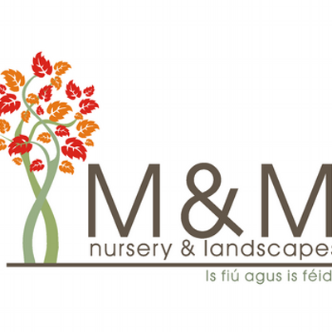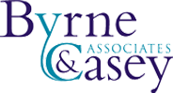

EmployAbility – “Building an Inclusive Workforce”
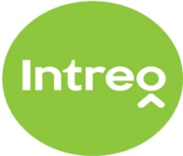

Chairperson’s Foreword 2015

On behalf of the Board of Directors I am delighted to present our 2015 Company Annual Report. I have been elected Chairperson of the company in a year when a number of important national initiatives were announced, including the publishing of the Government’s Comprehensive Employment Strategy for People with Disabilities. We believe that the EmployAbility Service is firmly established as an integral part of this strategy with the service being identified as a key vehicle for delivering a number of the strategic actions including; Providing Bridges and Supports for Work, Making Work Pay & Engaging Employers. Furthermore, through delivery of the above strategy, Supported Employment Services, such as EmployAbility, has being identified as playing a central role in helping Ireland ratify the UN Convention on the Rights of People with Disabilities by Ms. Catalina Devandas Aguilar, Special Rapporteur on the rights of people with disabilities to social protection.
In 2015, DSP appointed Indecon Economic Consultants to carry out a full independent evaluation of the EmployAbility service the results of which will guide the future development of the service. We will assist the consultants in any way we can and we look forward to receiving their findings and recommendations.
EmployAbility aims to match job seeker’s abilities with employer’s staffing needs. The service offers people with disabilities the critical supports to enable them to gain & maintain a foothold in the open labour market while supporting employers to meet their corporate social responsibilities through building a more diverse and inclusive workforce
Crucially, the successful outcomes achieved by our hard working & dedicated team is only possible with the ongoing support and participation of local employers, who have not been found wanting when approached by EmployAbility.
The Board would like to acknowledge the support of the Department of Social Protection in providing the core funding to deliver service. Our Employment Officers continue to enjoy good working relationships with local Intreo personnel throughout the Midlands enabling us to provide the best possible service to our job seekers.
Finally, I would like to acknowledge the time, support and expertise given freely by my fellow voluntary Directors, in guiding the company toward achieving its vision, mission and objectives, the Coordinator, Mr Tony Reilly who supports the Board in its function and the staff for implementing the company’s vision.

Susan Ryan
Chairperson

COMPANY MISSION

“Supporting people with disabilities into paid employment while providing effective solutions to employers’ staffing needs”

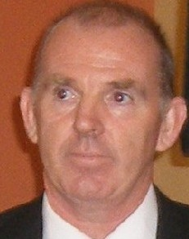

Introduction

2015 was another successful year for EmployAbility Midlands during which we secured our highest number of jobs ever for our service users.
I would like to acknowledge the commitment and dedication of the entire team who secured these successful outcomes by constantly striving to establish and develop good long term relationships with many willing employers throughout the midlands.

EmployAbility exists to provide the critical supports needed by Job Seekers with a disability/illness wishing to join the labour market while also providing the supports an employer may require in order to employ such individuals.

During 2015, DSP appointed Indecon International Economic Consultants to carry out a full independent review of the national EmployAbility service, the results of which will guide the future development of the service.

EmployAbility is now included in the menu of services available under DSP’s newly launched Intreo service. This has resulted in the service being more visible & accessible to both employers and job seekers with support needs.

Finally, I would like to thank our Board of Directors who generously give their time, knowledge and expertise in governing the company and ensuring that as the service develops, we are always mindful of the service user and their needs.

Tony Reilly
Coordinator.

EmployAbility Service

“Supporting people with disabilities to secure and maintain employment.”

While initially based on the Supported Employment model which was developed for people with learning difficulties, the National EmployAbility Service demonstrates that the service can successfully be applied to all disability groups.

As a strategy for enabling people with disabilities to access open employment, EmployAbility Service is based on the following key principles:

- Placements in the open labour market
- Support throughout the entire process
- Paid employment
- Integration

EmployAbility supports Job Seekers:

- To identify skills and abilities
- By facilitating work experience placements
- To find a suitable job
- With ongoing support during and after work

EmployAbility supports Employers by:

- Providing advice and assistance on grants and financial supports
- Helping to recruit the right person
- Providing jobseekers on a short trial basis, free of charge
- Providing on-site support with induction and training
- Providing jobseekers to fill positions with short or irregular hours

National EmployAbility Targets

Current targets require that each Employment Officer endeavours to:
- Work with 25 job seekers at any time
- Maintain 50 % of that number in employment
- Ensure that 50% of job seekers who exit the service do so while in employment.

Evaluation of EmployAbility Service

During 2015, DSP appointed Indecon International Economic Consultants to carry out a full independent review of the national EmployAbility service, the results of which will guide the future development of the service.

The national EmployAbility Service is a service dedicated to improving employment outcomes for jobseekers with a disability. In line with the United Nations Convention on the Rights of Persons with Disabilities, the service’s overall vision is to support people with a disability to secure and maintain employment and it aims to stem the flow of people with disabilities and extra support needs into long – term unemployment by facilitating integration into suitable and fulfilling mainstream employment.

The evaluation will examine the effectiveness & efficiency of the service; the appropriateness of the governance structures; & the scale and scope of service provision. The research methodology aims to include extensive new primary research among service participants including clients and employer organisations, in depth engagement with the EmployAbility service, DSP and external stakeholders, and detailed analysis of programme data on activities and outcomes.

The assessment of effectiveness and efficiency in relation to the operation of EmployAbility will include:

- An assessment of the level of positive outcomes achieved.
- The sustainability of the employment outcomes achieved.
- The appropriateness of the current key performance indicators.
- The appropriateness of the criteria applied for access to the service.

Finally the evaluation will present proposals and recommendations that will shape and guide the future delivery of the service.

Achievements

In 2015 we achieved the following quantitative outcomes:

- Delivered the service to 279 participants
- Sourced 128 new referrals in 2015
- A total of 129 job seekers exited our service in 2015

A total of 163 individuals achieved a positive outcome as follows

- New jobs secured in the open labour market 70
- Internships secured 03
- Formal work experience 78
- Community Employment 04
- Referred for further vocational skills training 08

In 2015 a total of 39 job seekers exited our service while in employment having completed the support & aftercare stages of the service.
During the year 235 individuals were supported in maintaining & developing their placements.
Furthermore, through the continued promotion of our national EmployAbility brand we demonstrated that the service can be successfully applied to all disability categories. Our regular outreach services throughout rural areas, has ensured that all eligible individuals can avail of our service, regardless of location.

Excellence Through People
Excellence through People is Ireland’s national standard for Human Resource Development which EmployAbility secured through aligning best practice Human Resource Management systems with Business Development. In 2015, EmployAbility Midlands was selected as one of 5 EmployAbility Companies to take part in the annual ETP audit/review process. The Coordinator, Administrator and an Employment Officer met with the assessor where we were interviewed on various aspects of our Human Resource Systems and practices. Following a successful review, the assessor confirmed that the national EmployAbility service would maintain the ETP award for a further year.

Outreach Service
The EmployAbility Midlands Outreach Service continues to be of great benefit throughout the midland counties. It brings the service to those who find it difficult to get to the bigger towns and promotes strong links with existing services within local communities. We currently facilitate regular Outreach Services at various venues throughout Longford, Westmeath, Offaly and Laois. For up-to-date details please visit www.employabilitymidlands.com

Referrals
The working relationship that exists between our Employment Officers, DSP Employment Service’s staff and disability service providers is crucial to the success of the service. Sharing of information, expertise and consultation between the organisations has ensured that the end user receives a professional service in an effective and efficient manner. This approach had a significant impact on the numbers of people presenting to EmployAbility Midlands service in 2015, as the statistics below verify. We received 128 new referrals in 2015 and the chart below gives a breakdown of that number.

Referral Source 2015

Other Category includes – Jobs club, NCBI, EDI Centre, MRC.

Workplace & Wage Subsidy Scheme
Traditionally, we have found that some of our service users don’t always demonstrate their abilities at interviews. The Workplace Scheme allows for job seekers to avail of a work experience placement with employers for a 5-7 week period at no cost to the employer and receive €20 per week subsistence from the EmployAbility organisation. Results are indicating that this scheme has the potential to secure more employment opportunities for our job seekers.
The Wage Subsidy Scheme is a DSP/Intreo workplace support which provides financial support to employers to encourage them to employ people with disabilities where a shortfall in productivity exists. Where appropriate, we have supported employers in applying for this scheme & we firmly believe that the combination of support from WSS & EmployAbility were crucial to securing an increased number of employment placements.

Job Shadow 2015
Having initiated and developed Job Shadow, we are very proud to see its popularity growing and being utilised all over the country by other EmployAbility Services. We continue to find it a useful tool for employers to experience the different types of disability along with the on-site support available from EmployAbility Midlands, and for jobseekers to showcase their abilities where it matters.

Referrals by Disability Category 2015

D
Marketing and Promotion

As part of our marketing & promotion strategy in 2015, EmployAbility Midlands continued to operate a number of outreach services in order to promote our service amongst individuals and communities. In 2015, EmployAbility is well established under DSP’s Intreo service which makes us more visible to both employers and job seekers.
Our Employment Officers in Athlone are involved in the Midlands Business Network. They meet weekly with employers where ideas, information and leads are shared.
As part of our marketing strategy, EmployAbility Midlands has put significant effort and time into developing effective networks in order to promote a quality service.

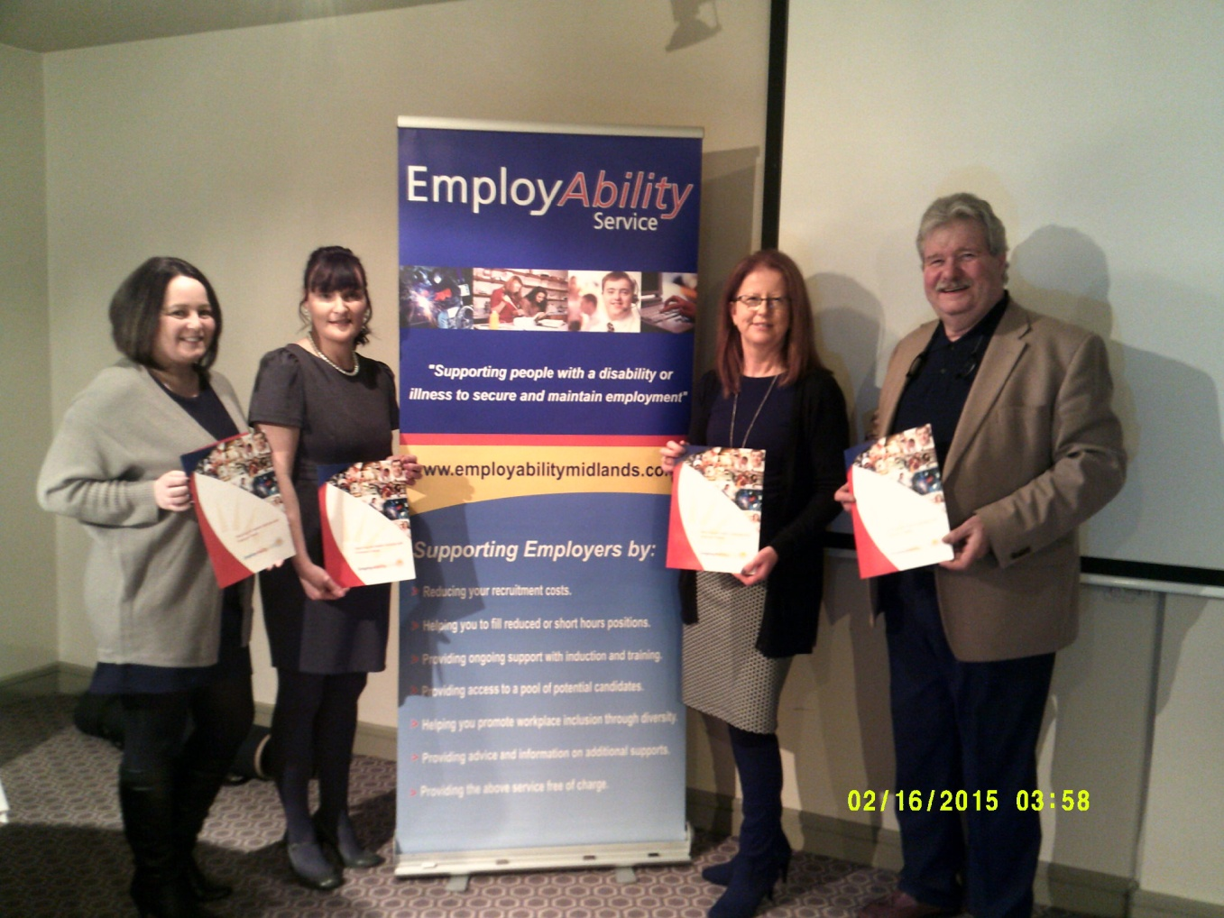

EmployAbility Midlands is also represented on:
o The National Co-ordinators’ Forum.
o Westmeath Disability Working Group
o Athlone Business Network
o Longford Services to the Unemployed Working Group
o Athlone Mental Health Association

Participation in the above has enabled EmployAbility Midlands to contribute to the development of best practice in the service and to address issues in order to remove the barriers to employment for people with disabilities. Establishing and developing effective networks encourages, promotes and supports EmployAbility Midlands in delivering a quality service to our customers. A good interagency working relationship has assisted us in:
o Identifying potential referrals
o Identifying employment opportunities
o Sharing of information
o Identifying areas of best practice (Nationally & Internationally)
o Providing the best possible service for the end user

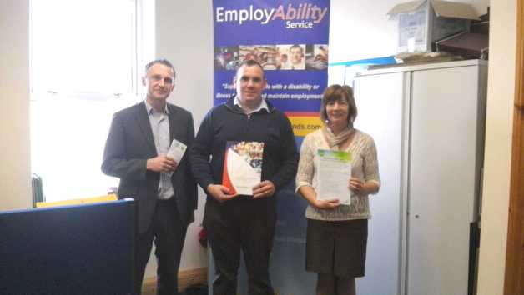
Eamonn Guilfoyle DSP, Daniel O Reilly, EmployAbility Midlands (Mullingar) and Anne Holt DSP.
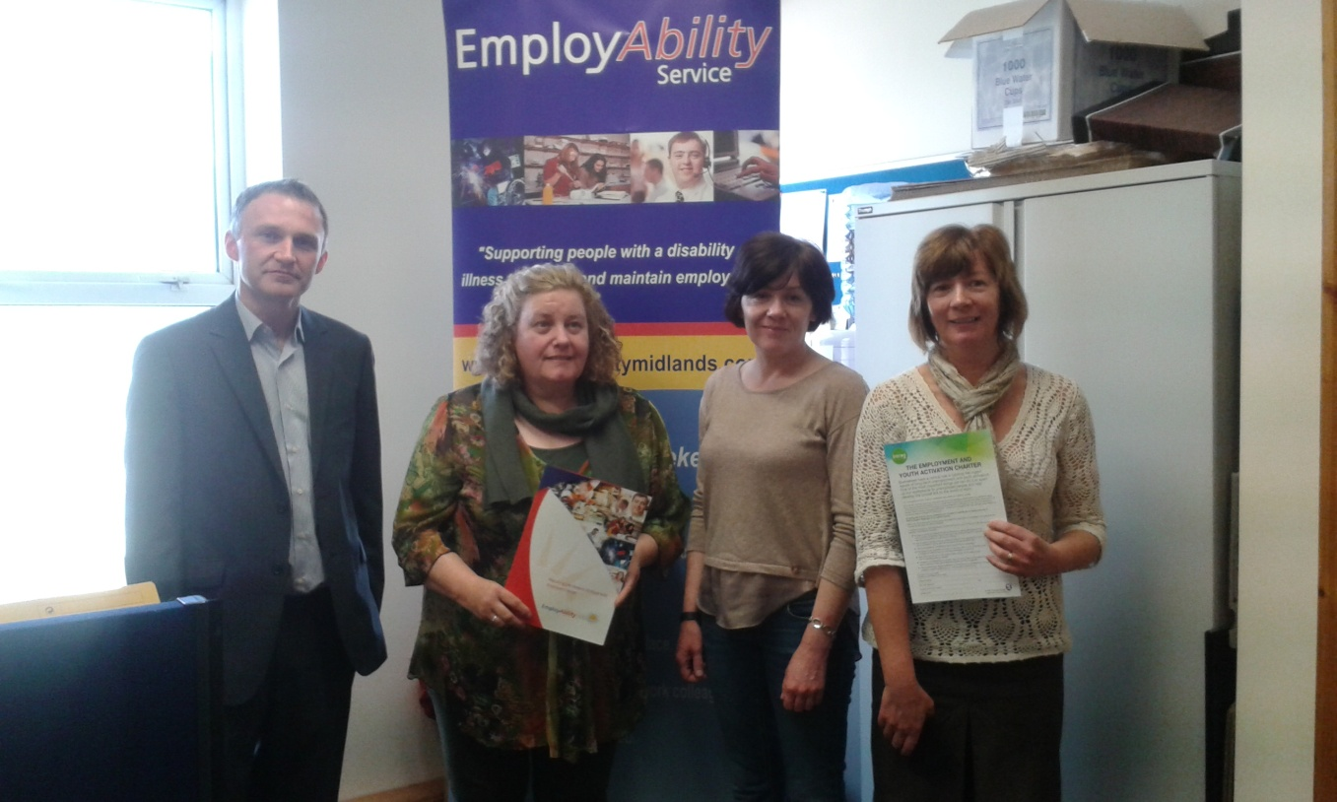
Eamonn Guilfoyle DSP, Joan Halpin-Hall & Rosemarie O Brien EmployAbility Midlands (Athlone) and Anne Holt DSP

Company Website
Our website is proving to be a very useful source of guidance and information for job seekers and employers. The total website hits for this year were 5714, on par with last year’s figures. We are continually working to improve our website and expect our new website will be live in early 2016.

Health and Safety
EmployAbility Midlands continues to be committed to a policy of safety at our offices in Laois, Offaly, Longford and Westmeath. We recognise our responsibility to provide an environment that promotes the highest standard of health and safety as set down by the Safety, Health and Welfare at Work Act 2005 and the European Union Law.
Health and Safety Audits were conducted in May and November in all five of our premises by our internally appointed Safety Officer. In 2015 we continued to uphold our policy of health and safety for all staff and service users.

Risk Assessment
Risk is part of everyday life and managing it effectively is essential if organizational goals are to be achieved and organizational assets are to be safeguarded. Managing risk is an integral part of governance and so the Board of Directors has ensured that a proper risk management strategy is in place. The risk management process at EmployAbility Midlands is a cyclical process and involves:
- Identifying risks
- Analysing them
- Controlling them
- Monitoring them

It is EmployAbility Midlands policy to conduct risk assessments regularly and then to document, prioritize & control each risk on our risk register. The register is reviewed regularly by the team with an annual formal review by the Board of Directors.

Employment Categories 2015

Other Category includes – Tyre Fitter, Mechanic Assistant, Caretakers

Regional Round-up

EmployAbility in Westmeath

Mullingar

2015 was a strong year for referrals in Mullingar. We took a broad range of people with a variety of different disabilities. We continue to receive referrals with a variety of agencies in Mullingar including The Mental Health Team, HSE, DSP, NLN, etc. 2015 saw us strengthen links with the new Intreo Service and we continue to work with them to develop the service and make it easier for clients to access our service and the supports that are available to them.
2015 saw an increase in the number of jobs obtained. 75% of our jobs were secured using the Wage Subsidy scheme and job placements began with us securing a work experience/job trial first so that the client could demonstrate their ability to the employer.
We continue to promote our service in North Westmeath. We gave presentations monthly at the Jobs Club. We attended a number of local information days including an information day for potential service users organised by Westmeath Enterprise Board, and a day organised by Westmeath Community Development. We have also increased our efforts to promote the service among employers. Presentations were given to numerous employers regarding the benefits of employing a person with a disability including Mergon in Castlepollard, Thomas Flynn & Sons in Mullingar and Lagan Cement in Kinnegad.
We continue to operate an outreach service on demand in Castlepollard and Ballinacargy and this has lead to increased service users from these areas.
We have also promoted the service through media. We also successfully had an article published in the Westmeath Examiner about Employability Midlands successfully obtaining Excellence Through People and we continue to promote our service through Facebook and our website.
Overall, Mullingar is making steady progress. Referrals are constant and we have a high proportion of people exiting the service in employment and able to maintain this employment with little intervention from us.

Athlone
The Athlone office of Employability Midlands enjoyed a very successful year in 2015 with internal and stakeholders targets being achieved and exceeded in some cases. “Effective networking” and “relationship building” were the key elements of this success. Through these elements we have accomplished solid sources of referrals through our engagement with other support agencies in our area, firm continued commitment from several employers which is aided by weekly attendance as a member of the Midland Business Network and a concrete relationship with our local Intreo office where we deliver fortnightly information talks to job seekers.
Our service gained increased publicity in the past year as a result of being included in the following; a major Jobs Fair organised by the European Employment Services which resulted in introductions to some multi-national employers, being included on the programme of events for the World Mental Health Awareness Week where we gave a daily talk on our services from which we received client referrals from and being asked to deliver a talk to AIT Social Care Students on our role in the community which lead to our first ever acceptance of a work placement student from the college.
Placing and maintaining employment continues to be an on-going challenge, however it is one which is made easier with the co-operation of employers, fellow agencies, Intreo and team colleagues at Employability Midlands.

EmployAbility in Laois

Referrals for 2015 were very steady and came through the Department of Social Protection’s Intreo Office, Portlaoise. The clients were referred to there from various organisations such as National Learning Network (NLN), HSE Occupational Therapists, Irish Wheelchair Association (IWA), Acquired Brain Injury (ABI) and Self-Referrals etc. Attending the Jobs club once a month to inform the participants of our service also helped gain awareness of our service within the community.
Our service here in Laois has a very good relationship with the staff in the Intreo Office Portlaoise. They are very good at dealing with queries that we or any of our clients would have. We are indebted to the CE Scheme Supervisors who accommodate us very well by allowing us use of an office space in which to meet our clients, on an outreach basis, around the different towns and villages of Co Laois.
I would like to take this opportunity to thank the employers of Co Laois for their time and the continued support they show to our service. The majority of employers in Co Laois were very accommodating in 2015 and gave work experience where they could and at times this work experience turned into paid employment. One particular client had two articles published in the local newspaper while on work experience which gave him the confidence to start a course in journalism. We also took part in Job Shadow Day in April 2015 and it was a great opportunity for our clients to take part in work experience for the day. We also had an article regarding this published in both local newspapers The Leinster Express and The Laois Nationalist. The Laois People published an advert in their September issue which yielded two employers contacting us about our service.
Along with my colleagues a great team building day was had at Lough Key Forest and Activity Park, Boyle, Co. Roscommon. Along with our team meetings these days are invaluable. As we are situated in different counties in the Midlands and don’t get to see each other on a daily basis they are a great way to catch up. Overall 2015 was a productive year for Co Laois.

EmployAbility in Offaly

Looking back over the year, there were a number of highlights in 2015 throughout Offaly. Unusually for 2015, our challenge was in managing demand for the service rather than generating referrals as we had a short but consistent waiting list for the service which seemed to grow every time we thought it was diminishing. Our strong links with colleagues in DSP and Intreo continued to develop and we are delighted to witness the benefits of this collaborative approach to the service that our job seekers now receive as a result of this good working relationship.
Training and development was to the fore in 2015. We had an excellent training workshop on Asperger’s Syndrome, which was delivered by Aspire. This provided an opportunity for invaluable information and insight to this condition as well as discussion around specific issues and queries. The team also had a team training & building day at Boda Borg centre in Lough Key, Co. Roscommon where we had to work together to solve a plethora of challenges and puzzles. These activities help reinforce the concept and benefits of individuals working together as a team when tackling any project.
This year was also very busy around Offaly regarding the promotion of the service & spreading the word. We took part in a number of initiatives including;
- Tullamore Chamber Speed networking event
- Information morning with Inclusion Ireland
- SOSAD information Night
- EmployAbility Job Shadow Day
EmployAbility Midlands was a finalist in the Tullamore Chamber of Commerce Business Awards which recognizes an organisations contribution to the community.
Finally, I would like to thank all the many employers who engaged with us over the past years. Without your generous support and willingness to engage, the service cannot work.

EmployAbility in Longford

2015 was a very busy year for EmployAbility Midlands in Longford. Referrals to the service were steady and our Outreach service continued on a monthly basis in Granard and Ballymahon. Employment and work experience opportunities presented themselves regularly throughout the county.
We are on the committee of Services to the Unemployed in Co Longford and met throughout the year to discuss various issues and possible solutions to Longford’s unemployment situation with ourselves here in EmployAbility Midlands focusing on employment opportunities for people with disabilities.
As always, we enjoy a great working relationship with our colleagues in the Intreo/DSP offices here in Longford, through which all our referrals get their final approval.
As a team we meet every six to eight weeks in our Head Office in Tullamore. These meetings are invaluable to us as we can discuss issues and problems we have encountered and also discuss solutions that worked well too. Once a year we go on a team building exercise which serves to enhance our own good working relationships.

Board of Directors

Ms Susan Ryan Ms Deirdre Fox
Manager Business Consultant
(Citizens Information Centre) (Self Employed)

Mr Tony Corry – Secretary Mr Adrian Stewart
Sector Manager Regional Manager
(HSE) (NLN)

Tony McCormack Mr Hugh Farrell
President Regional Manager
(Midlands Gateway Chamber) (I.W.A)

EmployAbility Midlands - Locations
In 2014, EmployAbility Midlands provided a service in the counties of Laois, Offaly, Longford and Westmeath. Details of office locations are as follows:

TOWN | LOCATION
TULLAMORE  (Central Office) | Unit 53, 1st Floor, Bridge Centre, Tullamore,  Co. Offaly Tel: 057 93 23901 / 086 3873 047
MULLINGAR | C/o Friary House, Friars Mill Road, Mullingar,  Co. Westmeath Tel: 086 8338 027
MOUNTMELLICK | C/o Mountmellick Development Association, Irishtown,  Mountmellick, Co. Laois Tel: 086 3873 056
LONGFORD | C/o Dawn learning Centre, Grafton Court, Longford,  Co. Longford Tel: 086 3872 855
ATHLONE | C/o Parish Centre, Chapel Street, Athlone,  Co. Westmeath Tel: 086 3872 496(Joan) 086 8337 946 (Rosemarie)

